Boys & Girls Clubs of Greater Peoria

Member Handbook

Our Mission
To enable all young people, especially those who need us most, to reach their full potential as productive, caring, responsible citizens.

2/5/2024
Our Clubs
East Bluff Unit Grinnell Unit
512 E Kansas St 2703 W Grinnell St
Peoria, IL 61603 Peoria, IL 61605
309-215-6902 309-215-6900
Site Director: Kelly Beal Site Director: Cenetha Hill

Program Director: Stephanie Rohrer, 309-685-6007, ext. 122, srohrer@bgcpeoria.org

Assistant Program Director: Aaron Williams, 309-685-6007, ext. 106, awilliams@bgcpeoria.org

School Year Hours: Monday – Friday, 1:00 pm to 6:00 pm
Each Club will be closed during District 150 School Year designated holidays and Teacher Institute Days.

Summer Hours: Monday – Friday, 7:30 am to 6:00 pm
Closed – Juneteenth and Independence Day

Ages Served:
Boys & Girls Clubs of Greater Peoria (BGCGP) serves youth 6 to 18 years of age. Members are placed in groups according to their grade as aligned with their school.

Ratio: staff to member ratio is 1:20.
If your child requires one on one care, we can refer you to other services.

Meals:
School Year: - Snack served upon arrival.

Summer – Breakfast, snacks and Lunch will be served to members daily at no extra charge.

Orientations:
All members and parents/guardians are required to attend one orientation session to review Club expectations, rules, program, field trips, etc.

Orientations are held during Club shutdown before the school session and summer session begins. If a member signs up after an orientation, the member and parent/guardian will be asked to schedule a time to go over this material with the Club Director.

Orientations are a requirement of Boys & Girls Clubs of Greater Peoria (BGCGP). If a member and their parent/guardian do not attend an orientation, membership will be revoked without refund.

Programs
Boys & Girls Clubs are a program-based organization. Members will participate in programing that focus’ on five core areas:

Education and Career Development
Character and Leadership Development
Health and Wellness
The Arts
Sports and Recreation

Programming in each of the five core areas will be done weekly. The Clubs also offers Power Hour daily throughout the school year. This gives members an opportunity to work on homework, as well as seek homework help. BGCGP staff cannot force a member to work on homework at Club. However, it is highly recommended that members complete their homework during the allotted time. If a member chooses not to take advantage of this time, other educational activities are offered.

Field Trips
Throughout the year there are many field trips offered through Club. Attending a field trip is considered a privilege, not a right. Participation in field trips is dependent on a member’s behavior and attendance. If a member loses their field trip privilege on an all Club field trip day, they are not allowed to attend Club that day.

All field trips are on a first come, first served basis. Permission slips are required for all field trips. Permission over the phone is not acceptable. When applicable, field trip fees must be paid to reserve a member’s spot.

Vans leave on time and will not wait for members to arrive.

Members must wear a Boys & Girls Club shirt on every field trip to allow for easy identification and help ensure member safety. Shirts are provided and kept at each site to ensure they are available when needed.

Attendance
When school is in session, a member cannot come to Club if they miss school due to illness or suspension. Local schools are aware of our policy and will contact the Club Director if a member is suspended. If part of the school day is missed due to an appointment, members are allowed to attend Club. Parents or school will be called to confirm.

Members are not required to attend Club daily. However, due to limited capacity, if a member misses two consecutive weeks of Club a parent/guardian will be notified that the member has been moved to the wait list to allow space for other youth.

Members who attend Club regularly are eligible for additional field trips, participation in sports, and BGCGP events.

If a member is going to be absent for the day, late, or picked up early, please be sure to send a message on remind or contact your Club Director as soon as possible.

Illness
If a member is home sick or sent home from school, they are not allowed to return to Club until they are 24 hours fever free, and their symptoms have subsided.

If a member requires antibiotics or another form of treatment, they are not allowed to attend Club until they have been treated for over 24 hours.

Members who become ill at Club, staff will contact parents/guardians and require members to be picked up immediately. Members showing signs of illness will be quarantined as they wait to be picked-up. BGCGP staff cannot administer medication.

We ask that anyone who tests positive for COVID-19 stay home according to Government guidelines to prevent the spread of the virus throughout our Club spaces.

COVID-19 is fluid, and we reserve the right to adjust policies and procedures as needed to maintain the health, safety and will-being of our staff and members. Any changes will be communicated to staff and families.

Masks are encouraged, but not required at Club.

Emergencies
If a medical emergency occurs at Club, staff will make every effort to contact a parent/guardian. However, if the emergency requires immediate medical attention beyond what staff can provide or parents/guardians are not reached in a timely manner, staff may call for an ambulance.

Staff are not allowed to transport members in their own vehicles for any reason.

Contact Information
In the event of an emergency or illness, it is important we have the most up-to-date information for all members. Contact your Club Director immediately if there is a change of address, phone, and/or emergency contact.

Medications
BGCGP Staff cannot administer any medications. It is highly encouraged that members requiring emergency medication such as an inhaler or EpiPen keep it on their person or in their backpack. Club Directors MUST BE notified.

Members must supply and be able to apply their own sunscreen/bug screen for field trips.

Pick Up Policy
Members must leave promptly at the end of each day. We request you pick up your child between 5:30 pm – 6:00 pm. Pick up after 6:00 pm will result in a charge of $1 per minute. Late fees must be paid prior to a member’s return.

If a member has not been picked up 5 minutes after Club closes, phone calls will be made to parents/guardians and emergency contacts. It is up to the parent/guardian to ensure this information is up to date.

If a member is not picked up after a half an hour after Club closes, and no one has been reached, Club staff will call the non-emergency line and have a police officer pick up the member. Frequent late pickups will result in the member being suspended from Club.

Members 13 and younger must be picked up from the Club by a parent, guardian, or another authorized adult. Members age 14 and older may escort other members of their household from the Club provided they have written permission.

Members will only be allowed to sign themselves out and walk home if a parent/guardian has indicated that on their member application. Parents should discuss with their child the importance of staying at Club until all walkers leave or you arrive to pick up your child. Once a member leaves, they are unable to return until the next day Club is open.

Staff are not allowed to transport member in their own vehicles.

BGCGP Van Transportation
Van privileges are not guaranteed for members.

Members must stay at Club for at least an hour to utilize van transportation. If a member misses the van at school, they will have to walk or find another way to get to the Club.

Members must arrive at the pick-up van promptly.
Guests and parents cannot take the van.
Members must wear their seatbelts.
Staff reserve the right to exclude any member from an activity or school pickups based on previous unruly behavior in the van.
Food and Beverages are not allowed in the van.

Inclement Weather
If schools are closed due to inclement weather, Clubs will also be closed. If schools close early unexpectedly, depending on the circumstances, Clubs may be open, but close early.

Communication will be made through social media and texts to primary contacts as listed on membership applications. If there is ever doubt, please call the Clubs or our Administration Office (309-685-6007).

Open Door Policy
The Boys & Girls Clubs of Greater Peoria has an “open door policy” for members. Members are allowed to come and go as they choose during the hours Club is open with the below guidelines:
- Staff cannot force members to come to Club directly after school.
- Staff will not force a member to stay at Club against their wishes. If a member leaves Club without walking permission, parents/guardians will be informed immediately.
- Once a member has left the building, they will not be allowed to return to Club in that same day, unless they are leaving with a parent/guardian for an appointment.

BGCGP welcome ALL youth and staff regardless of race, gender identity, ability to pay, religion, culture, national origin, and ethnicity. Therefor, we cover these topics with BGCA National Programs, such as LGBTQ Inclusion, SMART Girls, and Passport to Manhood. If you have concerns, please reach out to the Director of Operations.

Dress Code
Our policy at BGCGP is aligned with that of the School District. If a member wears something that would not appropriate at school, it would then not be appropriate at Club.

Members dressed inappropriately are required to be picked up and brought home to change before returning to club.

Members are expected to dress appropriately for the weather.

Lost and Found
Label backpacks, coats, and other items to assist in preventing lost items.

Parents/Members should check the Lost and Found regularly. Any unclaimed items will be donated. BGCGP is not responsible for lost items.

Personal Devices and Phones
BGCGP ask parents/guardians use caution when sending electronics to Club – BGCGP is not responsible for broken, lost, or stolen items.

Members bringing phones to Club will be asked to keep their phones in a dedicated space assigned by Club Directors. If a parent/guardian needs to contact their child, call Club and staff will allow you to talk with your child.

Due to safety precautions, personal videos and photos cannot be taken on a member’s own device. Members taking videos/photos will be asked to delete the media and potentially sent home early.

Other electronic (Chromebook, Kindles, iPads, iTouch, etc.) must be kept in backpacks. Members may be allowed to use electronics with permission during social rec time or under the direction of Club staff. Members are not allowed to bring video games from home.

Personal electronics are a privilege, not a right. If electronics are misused, a member will not be able to bring it until further determined by the unit director. Examples of misuse include taking video or photos, using them without permission, inappropriate content and/or language.

Club Computers
Access to Club technology is a privilege, not a right for members.

Members needing computer access for homework and/or access to school email have priority when using computers.

Club computers are used in structured programs to educate members about technology. Members not participating in these programs may not be allowed to utilize computers during Social Rec.

All websites used must be deemed appropriate by staff. Computers are not allowed for use of social media in any form. Members are not allowed to download anything onto Club computers. Members misusing Club computers in anyway (including bullying others), will be suspended.

Computer rules must be followed at all times or privileges will be revoked, until staff deems otherwise.
Bullying
Bullying is when one or more people exclude, tease, taunt, gossip, hit, kick, or put down another person with the intent to hurt that person. Bullying happens when a person or group of people want to have power over another and use their power to get their way, at the expense of someone else. Bullying can also happen through cyberspace. This type of bullying can also lead to people being physically hurt due to being targeted with meanness and exclusion.

At the Boys & Girls Clubs of Greater Peoria , safety is our top priority, and ALL members should feel safe. Bullying is inexcusable and will not be tolerated. Alert staff immediately if you see any form of bullying. Any member that engages in bullying behavior will be suspended from Club.

Member Expectations
To keep our Club a positive, fun, safe environment for members, members must follow Club rules, expectations, and guidelines when they are at club or participating in Club activities.
- Cursing or swearing in any language is not allowed at Club, on field trips, or at BGCGP sponsored events.
- No wandering around Club without permission from Club staff. Members must always be supervised.
- Use proper bathroom etiquette, including flushing after use and washing hands.
- Talking back and disrespecting staff is not tolerated.
- Touching members and staff in any manner is not permitted.
- Members must demonstrate good sportsmanship/teamwork – focus on how well everyone worked together, not who won.
- Phone calls are to be made at the discretion of Club Directors or in case of emergency only.
- Any items brought from home must remain in your backpack. Including hats, food, and money.
- No stealing. BGCGP is not responsible for lost or stolen items.
- Clean up after yourself.
- Keep hands, feet, and object to yourself always.
- Any form of defacement to Club property such as writing on walls, desks, tables, chairs, etc. will be held liable for damages incurred.
- BGCGP has zero tolerance for damage to club property, stealing, inappropriate language, bullying, violence, threats, gang signs, weapons, or use of drug and alcohol.
- Damage to any BGCGP property must be replaced and paid for by your parents/guardians.
- Members will not be allowed to play outside if temperatures are above 95 or below 35 for more than 30 minutes at a time.

Discipline and Guidance
Unacceptable behaviors including, but not limited to, will be handled as listed below

Minor Incidents | Major Incidents
Inappropriate Language  Dishonesty  Impolite Language/Swearing  Name Calling/Teasing/Gossiping  Negative Comments  Verbal Arguments | Inappropriate Language  Bullying  Harassment (racial, sexual, religious, etc.)  Talking Back to Staff  Threats/Intimidation  Vulgar Language
Physical Contact  Violating Personal Space  Arm Wrestling/Play Fighting  Public Displays of Affection | Physical Contact  Pushing/Shoving/Tackling/Pinching/Grabbing/Kicking  Fighting/Physical Aggression  Physical Intimidation  Inappropriate Touching/Touching Without Consent
Disrespect  Breaking Club Rules/ Uncooperative Behavior  Excluding others with the intent to be hurtful  Refusal to participate in programming  Misuse of Electronics  Disrespect of a staff, member, or volunteer | Disrespect  Bullying  Excessive Arguing  Weapons, drugs, alcohol, violence, etc.  Leaving site abruptly & without signing out or telling an adult
Property Misuse  Disrespect of Club property/School property  Writing on club property (tables, walls, etc.)  Going into/taking/touching other people's property without permission  Breaking Club Computer Lab policy | Property Misuse  Destruction of club, peer, staff, school property  Major Graffiti  Stealing  Vandalism
Disruption  Talking that disrupts or inappropriate noise during programming.  Throwing objects.  Cell phone use during programming. | Field Trip/Van  Refusal to wear seatbelt, club shirt  Refusal to follow Club rules, etc.
Minor Incident Procedure | Major Incident Procedure
1st Minor Infractions/Incidents = 1st Strike  - Documentation of incidents (Behavior Tracking)  - Completion of “Think Sheet”  - Discussion with youth about why they received a strike  2nd Minor Infraction/Incident = 2nd Strike  - Documentation of incidents (Behavior Tracking)  - Completion of “Think Sheet”  - Discussion with youth about why they received a 2nd strike  - Parent notified  3rd Minor Infraction/Incident = 3rd Strike  - Documentation of incidents (Behavior Tracking)  - Discussion with youth about why they received a 3rd strike  - Parent notified with Disciplinary Warning | 1st Write-up = 1st Strike  - Club staff will talk to member and parent will be notified  - Parent must pick up member immediately  - Member may be suspended depending on incident  - Member is not eligible for the next Club sponsored Field Trip  2nd Write-up = 2nd Strike  - Club staff will talk to member and parent will be notified  - Parent must pick up member immediately  - Member is suspended for 2 Club days  - A meeting with the club director is required before member can return to club  - Member is not eligible for the next 2 Club sponsored field trips  3rd Write-up = 3rd Strike  - Parent must pick-up member immediately  - Member will be placed on a behavior contract and suspended for 5 days  - Parents must sign the contract before member is allowed back to club  - Member cannot attend Club sponsored field trips during their probation period
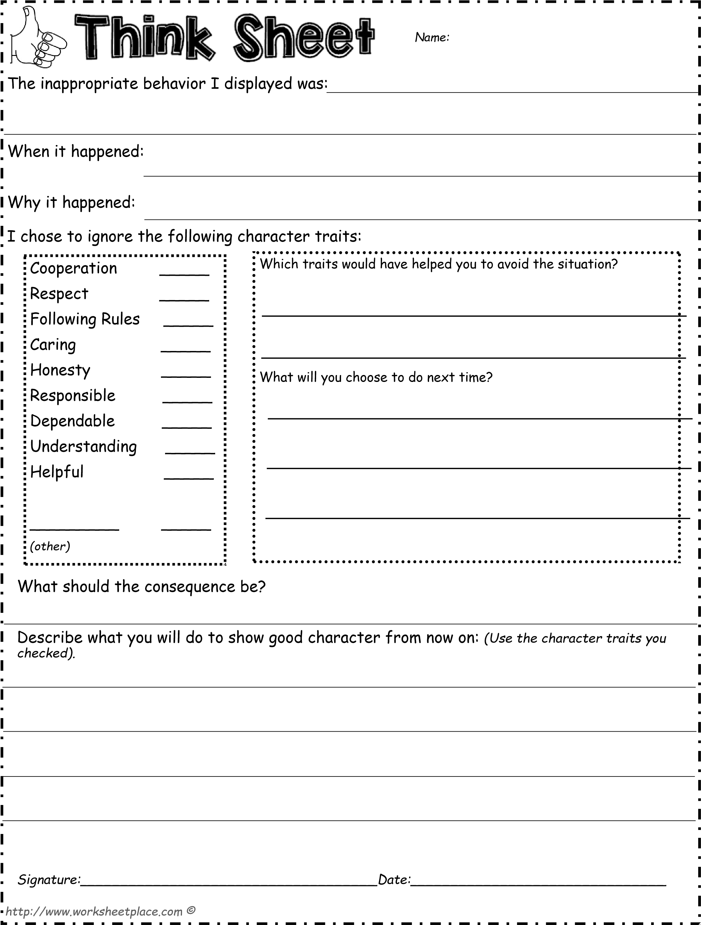

Safety in Club
At Boys & Girls Clubs of Greater Peoria, child safety is our top priority. Ensuring the safety and well-being of young people is fundamental to the mission of our organization. BGCGP works to create a safe and fun environment so youth/teens can have every opportunity to reach their maximum potential. We have zero tolerance of inappropriate behavior of any kind, including child sexual abuse or misconduct.

Culture of Safety: BGCGP updates safety policies and requires annual training for our employees and volunteers, that are designed to promote child safety and protect young people from threats that exist in our society. We implement safety policies and guidelines to keep our members safe including, but not limited to:

- Mandatory criminal background checks for employees, board members and volunteers annually.
- Prohibiting one-on-one contact. This includes supervision and transportation of members as well as communication between members and staff.
- Staff are required to immediately report any incident to the appropriate authorities as well as to the Boys & Girls Clubs of America (BGCA).
- BGCGP has a Board-led Safety Committee that meets regularly to elevate safety to the highest level of governance.
- BGCGP is mandated by BGCA to complete annual safety assessments to continually make improvements to safety in our Clubs.
- Staff engage leading third-party safety experts on training, policies, and resources.
- Child safety training, ongoing training, and supervision of staff is critical. Staff participate in mandatory training before engaging with members and annually while employed in Clubs.
- All employees undergo and must pass reference checks.
- BGCGP encourages all employees, members, and families to report any incident or situation they feel is unsafe. BGCGP members and employees have access to a confidential 24-hour toll free child safety hotline: (866) 607-SAFE.

Youth/Adult Interaction Guidelines
The Boys & Girls Clubs of Greater Peoria follows the Mandatory Reporter Guidelines policy on child abuse:
- Staff members should never be alone with a Club member out of sight of others.
- Hugs are permitted if initiated by members and/or are side hugs.
- Members are not allowed to accompany staff or volunteers to their private residences.
- Allegations of abuse made against BGCGP’s team, will result in restricted contact, as allegations are investigated immediately and reported to the proper entities.
- BGCGP reserves the right to dismiss or exclude from affiliation with any member, volunteer or employee who is found guilty of child abuse or neglect or has been convicted of child abuse or neglect.
Equal Opportunity Provider
The Boys & Girls Clubs of Greater Peoria is committed to providing equal opportunity for all participants regardless of race, creed, color, religion, gender identity, familial status, national origin, citizenship status, disability or any other characteristic protected by law. Therefore, we welcome all youth!

We will attempt to provide reasonable accommodations for all youth but are unable to provide one-on-one supervision.

Stance Against Racism
Boys & Girls Clubs of Greater Peoria commits to being a safe place where kids of all races and backgrounds are encouraged to have difficult conversations and stand up for what’s right. Boys & Girls Clubs condemn all forms of racism and discrimination, and we will use our national platform to help demand and deliver change.

You can expect from BGCGP:
- Staff and Boards are well-trained in anti-racism and equity.
- Programs are created through the lens of diversity, equity, and inclusion.
- Policies are reviewed and designed to close the gap that exists at the federal, state, and local levels to help shape a robust and sustained advocacy strategy.
- All partners are examined to ensure they represent racial justice and equity.

Organization Contact Info

Administrative Office Hours: 9:00 am – 4:30pm
806 E Kansas Phone: 309-685-6007
Peoria, IL 61603

Chief Executive Officer
Christian Lee, 309-685-6007, ext. 111
clee@bgcpeoria.org

